Amundsen-Scott South Pole Station, South Pole Antarctic Specially Managed Area (ASMA No. 5)
2010 Management Report

Amundsen-Scott South Pole Station, South Pole Antarctic Specially Managed Area (ASMA No. 5)
2010 Management Report
Introduction
The Amundsen-Scott South Pole Station, South Pole, operated by the United States Antarctic Program (USAP) was formally adopted as Antarctic Specially Managed Area (ASMA) No. 5 by Measure 2, ATCM XXX (New Delhi, 2007). Increasing human activity led the United States to propose the ASMA with the purpose of more effective management and coordination of activities in the Area. The proposal for ASMA designation was made to ensure that the scientific, environmental, and historical values of the Area would be conserved. ATCM XXXI IP 109 described the experiences and challenges encountered during the Management Plan’s first year.
This paper summarizes the continuing challenges in managing activities including diverse scientific research endeavors and operations in support of science, media, arts, education, and tourism. In particular, issues related to non-governmental activities continue to be a challenge in this remote and extreme environment.
Management Activities
The aim of management at South Pole is to coordinate activities in the Area such that the scientific and environmental values of the Area can be sustained indefinitely, and the historical values preserved to the greatest extent practicable. As the operator of Amundsen-Scott South Pole Station, the United States volunteered to take the lead in coordinating activities in the South Pole ASMA. Management activities undertaken to achieve the goals of the plan focus on advanced planning and coordination of research activities conducted by National Programs working in the area and coordination of visits by tour groups and other non-governmental organizations (NGO) activities. Additionally, National Programs working in the Area and NGO groups visiting the Area are to ensure that their respective personnel/participants are aware of the requirements of the management plan.
Restricted and Managed Zones within the Area
This management plan establishes four types of managed zones within the Area: Operational Zones, Scientific Zones, Historic Zones, and a Hazardous Zone. The objective of this zoning concept is to manage multiple uses of and activities in the Area
Observations on Management of the Operations Zone
Removal of the Geodesic Dome
During the 2009-2010 austral summer, the geodesic dome, an icon of the 1975 station, was deconstructed. The tall wooden structure adjacent to the dome, Skylab, was also removed, as were ancillary connecting arches, utilidors, and the dome’s foundation. All materials resulting from the deconstruction were removed from South Pole to McMurdo where they were all placed on the annual resupply ship for retrograde to the United States. A large snow cavity was left after dome removal; snow grooming was performed to shape the sides of the site. Over-winter snow accumulation and drifting will likely make the majority of the cavity invisible by the beginning of the 2010-11 austral summer season.
Location of the Ski-way
The Operations Zone includes the ski-way, which is essential to the operations and safety of researchers in the Area. A 2006 review of the flight operations by the USAP identified safety concerns with regard to the location of the ski-way. In order to improve the safety of operations, the ski-way was shifted approximately 5000 ft (1500m) to grid South. This shift removed the connector trail between the Operations and Dark sectors from the active ski-way. Now, routine vehicle and foot traffic between the primary station facilities and the science functions in the Dark Sector do not have to cross an active airstrip, greatly reducing the potential for accidents. The new position of the ski-way is shown in revised Maps 2, 3, and 4.

Observations on Management of Non-Governmental Activities
ATCM XXXI IP 109 concluded with the statement “With regard to NGO activities, the increase in number of visitors and events has put a large amount of pressure on Amundsen-Scott South Pole Station personnel and is beginning to show an impact on National Program science support activities. With a number of historic event anniversaries approaching, the U.S. Antarctic Program is already seeing increased interest in South Pole visits. The U.S. Antarctic Program is currently reviewing the Management Plan guidance for NGOs and its ability to engage in the current level of outreach activities”. This review has continued during the past two seasons and a number of issues have been identified. These are described in the following sections.
Numbers of NGO visitors to the Area
The trend in NGO activities (number of visitors and number of station tours given) are shown in Figure 1. The 2008-09 season showed a peak in NGO visitors (271) and station tours (37). Data from the 2009-10 season showed a marked decline in numbers of visitors compared to the increases during the previous three seasons. This decrease was likely due to the downturn in the economy. It is expected that NGO visits will increase as the economy recovers. Additionally, increased NGO activity is expected during the 2011-12 season as expeditions are being planned to commemorate the 100th anniversary of the Amundsen and Scott expeditions.
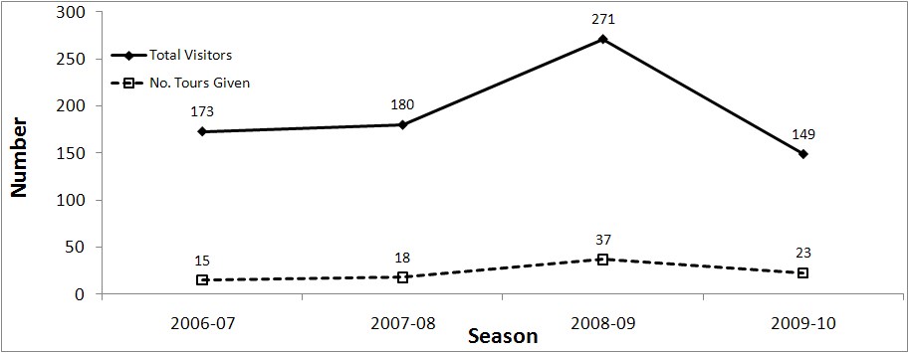
Figure 1- The total number of NGO visitors and station tours over a four year period
Location of NGO campsite
During the past two seasons, the USAP has seen an unexpected impact of NGO activities due to the location of the Designated Camping Area near the Amundsen-Scott South Pole Station (Figure 2). During the planning for South Pole Modernization Project, it was recognized that the construction of an above grade station was critical in order to avoid the eventual burying of the station due to drifting snow. Thus, the station was elevated on extendable stilts which allow for blowing snow to pass unimpeded under the station.
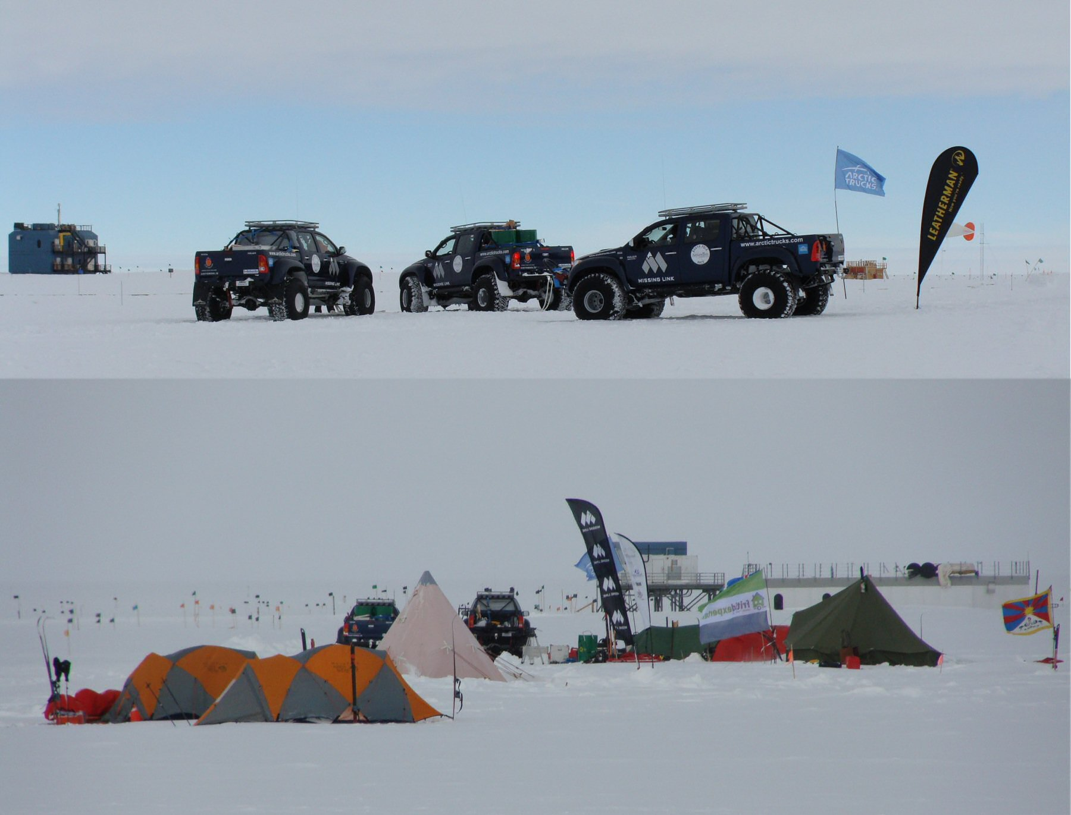
Figure 2- Designated Camping Area with decommissioned ASTRO building in the background

The original location of the NGO campsite is about 325ft (100m) upwind of the station. Increased NGO activity (i.e., tents and vehicles, some being in place for more than a month) during the short summer season at the South Pole resulted in significant accumulation of snow drifts between the camp and the station. During the 2008/09 season, these drifts were more than 6ft (2m) in height in several places, at least 30ft (10m) in length parallel to the elevated station building, and extended toward the station as much as 50ft (15 m) (Figure 3). The USAP used heavy equipment to knock down the drifts but concern was raised over the projected annual maintenance required to remove drifting due to the campsite being in such close proximity to the station.

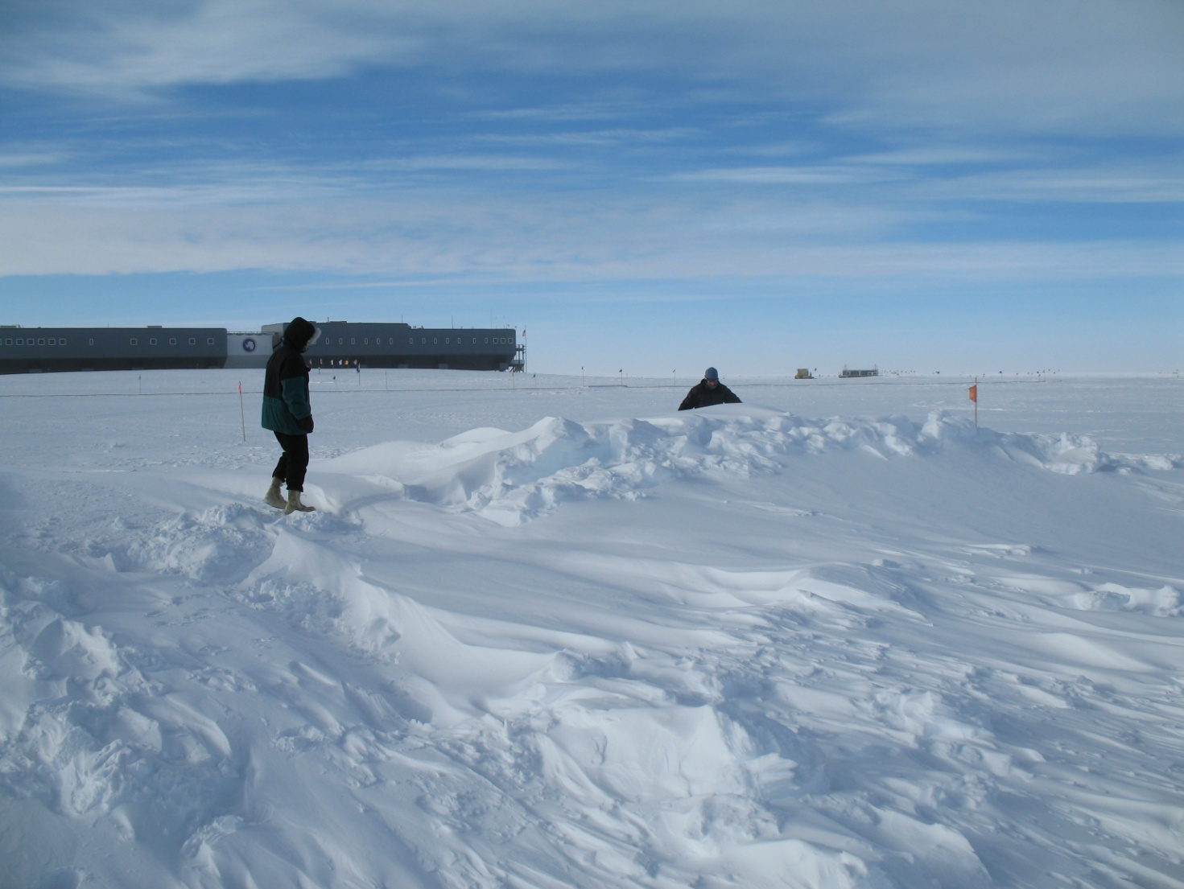
Figure 3- Snow drifts remaining after the tents and vehicles were removed from the Designated Camping Area

After discussions with stakeholders, a new location for the NGO activities was identified (Map 4). This site is located about 4000ft (1200m) grid North of the geographic South Pole marker and includes the Designated Camping and Cache areas. USAP will maintain a ski taxiway from the grid North end of the South Pole ski-way to the NGO site to ensure separation of station operations and science activities from NGO activities. The existing taxiway to the location of South Pole markers will also be maintained.

Surface Access route
A new route for surface based approaches was also identified (Maps 3, 4). The new approach was established in order to provide direct access to the new Designated Camping Area. Importantly, this new route improves safety of personnel and operations by bringing visitors to the geographic South Pole via a corridor completely separated from the ski-way and other operationally active areas. Once within 3 miles (5 km) of the geographic South Pole, all surface-based approaches to the Area should be made along a corridor between 800 and 1000ft (250 and 300m) offset to the east from, and parallel to, the 20°W (340°E) meridian. Approaches from the north, east, or south can interfere with ongoing scientific and operational activities in the Area.
Appendix A of the Management Plan provides guidelines for NGO visits to the South Pole. The intent of this additional guidance was to inform visitors about onsite resources, expectations, and hazards. The guidance includes information on approaches to the South Pole, guidance for aircraft, location of a Designated Camping area for visitors staying overnight in the Area, limitations of visits to station buildings, and the need to be self-sufficient. A revised Appendix A includes updated information on the Designated Camping Area and surface access route (attached). Most NGOs plan to take photographs at both the ceremonial and geographic South Poles. The USAP conducts guided station tours, when possible, in order to provide educational outreach. At times, station tours may be not possible due to operational or scientific activities of station personnel.
Medical Emergencies
Pursuant to a 1982 Presidential Memorandum, the National Science Foundation (NSF) is responsible for managing the United States national program in Antarctica. The NSF policy on private expeditions to Antarctica states, "The U.S. Government is not able to offer support or other service to private expeditions, U.S. or foreign, in Antarctica." The policy in full can be found at: http://nsf.gov/od/opp/antarct/ngo_policy.jsp The mission of the USAP is to support federally funded scientific research and provide environmental stewardship in Antarctica; therefore, its attention and operational/logistical assets are totally committed to that effort. However, in emergency situations, the USAP is prepared to attempt to provide assistance provided that there are no unacceptable risks posed to U.S. personnel and the assistance can be accomplished within the means available to the United States.
In addition, the NSF policy states, “Private expeditions, therefore, should be self-sufficient and are encouraged to carry adequate insurance coverage against the risk of incurring financial charges or material losses in the Antarctic. The National Science Foundation, as manager of the USAP, reserves the right to seek, in accordance with international and domestic law, recovery of all direct and indirect costs of any such emergency search and rescue.”
During the 2009-10 season, two NGO medical evacuations were conducted from the South Pole; these required varying degrees of involvement by the USAP. In December 2009, an employee of The Antarctic Company (TAC) became severely ill. The patient was examined by the USAP station physician, who recommended a medical evacuation. The medical evacuation was conducted by the TAC. In January 2010, a client of Antarctic Logistics and Expeditions (ALE) became severely ill. The USAP station physician concurred with the accompanying ALE physician determined that the patient required a medical evacuation. Although ALE had the necessary assets to fly the patient from South Pole to its base camp and then out of Antarctica, ALE came to the conclusion that it was in the best interests of the patient to request that the NSF deploy one of its pressurized aircrafts for an emergency evacuation to Christchurch, New Zealand. The NSF agreed and provided aircraft support with an experienced medical team to fly from McMurdo Station to the South Pole and evacuate the patient to New Zealand.
These two emergency medical evacuations involved risk and in the latter case, considerable assets of the USAP. The USAP is currently discussing the potential recovery of direct and indirect costs to the USAP associated with these two medical emergencies. It would be informative for the NGO operators to conduct a retrospective analysis of the circumstances leading to both NGO medical evacuations in order to (1) identify potential problems in medical screening procedures for those persons travelling to such an extreme part of Antarctica, (2) determine whether all potential assets (e.g., necessary medical personnel and supplies, sufficient fuel depots, etc.) are in place should a medical emergency occur, and (3) identify means to reduce the risk of medical emergencies.
Summary
Although the Management Plan provides the means for more effective management and coordination of activities in the Area, it will only be effective if all involved in planning and conducting activities within the ASMA are fully aware of the details of the Plan, fully engaged in advanced communication and coordination prior to the field season, and fully committed to the values that underlie the plan. Additionally, all activities conducted within the Area should be planned to minimize the risk to participants and impacts to national programs operating within the Area.
The move of the Designated Camping Area and change in access routes for surface-based approaches will be formally presented to ATCM XXXIV as proposed changes to the ASMA management plan. The 2010-11 season will trial these changes in order to ensure that the goals of increased safety and decreased impact to the Amundsen-Scott South Pole Station science and operations will be met. The United States will continue to report on experiences regarding implementation of the Management Plan in future years in order to inform discussion and to consider other potential modifications of the Plan.

