Amundsen-Scott South Pole Station, South Pole Antarctica Specially Managed Area (ASMA No. 5) 2012 Management Report

Amundsen-Scott South Pole Station, South Pole Antarctica Specially Managed Area (ASMA No. 5)
2012 Management Report
Introduction
An area encompassing Amundsen-Scott South Pole Station, South Pole, operated by the United States Antarctic Program (USAP), was formally adopted as Antarctic Specially Managed Area (ASMA) No. 5 by Measure 2, ATCM XXX (New Delhi, 2007). Increasing human activity led the United States to propose the ASMA with the purpose of more effective management and coordination of activities in the Area. The proposal for ASMA designation was made to ensure that the scientific, environmental, and historical values of the Area would be conserved. Previous reports have described management activities, challenges related to increasing non-governmental (NGO) activities, and introduced new maps and guidance for visitors in expectation of high visitor numbers associated with celebrations of the Centenary of Roald Amundsen and Robert Falcon Scott reaching the South Pole (ATCM XXXI IP109, ATCM XXXIII IP92, and ATCM XXXIV IP73). This paper summarizes the continuing challenges in managing diverse activities in the ASMA and discusses implementation the newly positioned primary camping area and the secondary (or overflow) camping area, and the implementation of a Visitor Center.
Management Activities
The aim of management at South Pole is to coordinate activities in the Area such that scientific and environmental values of the Area can be sustained indefinitely, and the historical values are preserved to the greatest extent practicable. Management activities undertaken to achieve the goals of the plan focus on advanced planning and coordination of research activities and official governmental visits conducted by National Programs, operations conducted for Station maintenance and visits by tour groups or other non-governmental organizations (NGO, collectively). Additionally, National Programs working in the Area and non-governmental groups visiting the Area are to ensure that their respective personnel/participants are aware of the requirements of the management plan.
ATCM XXXIV IP73 introduced two significant activities to address accommodating large numbers of visitors to the ASMA. The primary camping location was moved slightly grid east, so that it no longer abuts the hazardous zone and is no longer oriented on the centerline of the runway. Additionally, an overflow camp site was designated in anticipation of large numbers of visitors concentrated around the Amundsen and Scott centennials in the 2011/2012 season.
The second activity involved establishing a Visitor Center. The Visitor Center housed a number of informational displays about the Amundsen-Scott South Pole Station, the science conducted within the ASMA, and a branch of the station store.
The 2011/2012 season was relatively busy in terms of the numbers and amount of time non-governmental visitors were on station. There were two peak periods one in mid December and one in mid-January associated with celebrations for the Centenary of the Amundsen and the Scott expeditions reaching the South Pole. All visitors seemed aware of the changes to the primary camping area and designation of overflow camp area. The Visitor Center was well utilized. We are pleased to report that there was no further confusion with the overland access routes established during 2009/2010 season.

In 2012, the U.S. Antarctic Program began the process to produce the next revision of the Management Plan. We conducted an onsite review and plan to submit a revised plan to the CEP in 2013.

Observations on Management of Non-governmental Activities.
Number of non-governmental visitors to the Area
The trend in non-governmental activities (number of visitors and number of station tours given per season) is displayed in Figure 1. The ASMA received 495 NGO visitors (tourists, staff, and crew) during the 2011/12 season, a near doubling of visitors from the 2010/2011 season. There were two peaks in visitor attendance correlated with the celebrations for the centennial of Amundsen (December 14, 2011) and Scott (January 12, 2012) reaching the South Pole. During the period December 11-15, 2011, there were approximately 150 NGO visitors (tourists, staff and crew) in the ASMA, equivalent to the total number of visitors during the 2009/10 and 2007/08 seasons. During the period January 9-17, 2012 there were approximately 85 NGO visitors (tourists, staff and crew) in the ASMA. Some of the staff and crew visited the station multiple times during the season; they were counted each time they arrived.

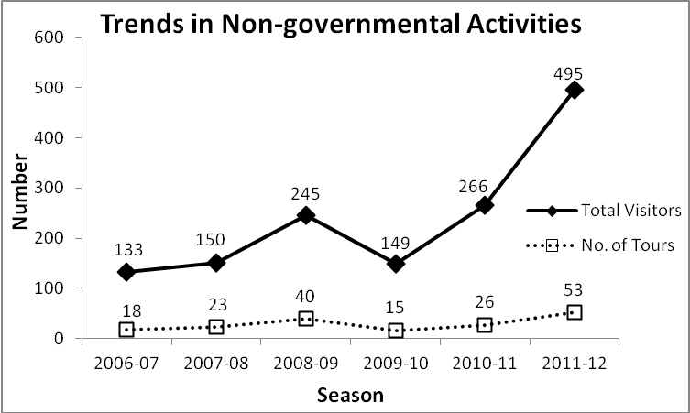
Figure 1: The total number of non-governmental visitors and station tours over a six season period.

Surface Access Route and Traffic Patterns within the ASMA
In ATCM XXXIV IP 73 from 2011, we reported on a number of incidents related to changing surface access route. Since then the routing has remained the same, and we increased the number of flags marking the route. We are pleased to say that we have no incidents to report this year.
Location of the designated non-governmental camping area
During the 2011/2012 season the primary non-governmental camping area was moved slightly grid east so that it was no longer on the centerline of the skiway or abutting the Hazardous Zone. Transit from the primary camp site to the South Pole markers and the Visitor Center was easy as all destinations were located on the same side of the skiway. The secondary campsite, designed to accommodate the larger number crowd of visitors expected during the time of the centennial celebrations, was used not used for camping this season. All NGO campers were accommodated within the primary campsite. Station residents and NGO visitors alike were pleased with the campsite locations and there are currently no plans for further adjustments.
Visitor Center
For the 2011/2012 season the United States Antarctic Program operated a Visitor Center. The Visitor Center was located along the NGO access route to the Pole markers, near the NGO day parking area. The Visitor Center housed educational displays and hosted educational presentations given by Station personnel (including seasonal workers and scientists). The Visitor Center served as a common meeting place where station residents and NGO visitors could freely interact. Finally there was a small store selling South Pole souvenirs. The Visitor Center was viewed as a success and a beneficial addition to the Area by visitors and station residents alike. The United States Antarctic Program is considering continued operation of the Visitor Center in future seasons.

Summary
Although the Management Plan provides the means for more effective management and coordination of activities in the Area, it will only be effective if all involved in planning and conducting activities within the ASMA are fully aware of the details of the Plan, fully engaged in advanced communication and coordination prior to the field season, and fully committed to the values that underlie the plan. Additionally, all activities conducted within the Area should be planned to minimize the risk to participants and impacts to national programs operating within the Area.
After two seasons in use, the “new” land based access routes seem to be working well. The move of the Designated Camping Area and improved on site marking of non-governmental routes and camping areas also seems to have been a success. It is anticipated that these changes will be formally incorporated into the Management Plan during revision process. We welcome comments and input from national programs and non-governmental organizations as we move forward with the Management Plan revision.

