Amundsen-Scott South Pole Station, South Pole Antarctica Specially Managed Area (ASMA No. 5) 2016 Management Report

Amundsen-Scott South Pole Station, South Pole Antarctica Specially Managed Area (ASMA No. 5)
2016 Management Report
Introduction
An area encompassing Amundsen-Scott South Pole Station, South Pole, operated by the United States Antarctic Program (USAP), was formally adopted as Antarctic Specially Managed Area (ASMA) No. 5 by Measure 2, ATCM XXX (New Delhi, 2007). Increasing human activity led the United States to propose the ASMA with the purpose of more effective management and coordination of activities in the Area. The proposal for ASMA designation was made to ensure that the scientific, environmental, and historical values of the Area would be conserved. Previous reports have described management activities, challenges related to increasing non-governmental activities, and introduced new maps and guidance for visitors in expectation of high visitor numbers associated with celebrations of the Centenary of Roald Amundsen and Robert Falcon Scott reaching the South Pole, and implementation of new camping areas and of a Visitor Center (ATCM XXXI IP109, ATCM XXXIII IP92, ATCM XXXIV IP73 and ATCM XXXV IP78).
The United States initiated review of the management plan for ASMA No. 5 in 2012. The range of activities, management requirements and constraints at South Pole is complex, and the work is on-going in 2016 with a view to submission of a revised management plan in 2017. This paper summarizes progress with the review and some of the diverse management issues being addressed.
Management Group
Consistent with the approach taken at several other ASMAs, for example for ASMA No.1 Deception Island and ASMA No. 2 McMurdo Dry Valleys, the United States has taken the initiative to form a Management Group for ASMA No. 5 with interested Parties. In particular, Norway expressed interest in participating in the group both because of its long historic association with the South Pole since Roald Amundsen led the Norwegian expedition that was first to reach the geographic South Pole on 14 December 1911 and the current level of non-governmental expedition activity involving Norwegian nationals.
A first meeting of the Management Group was held by international video link on 11 August 2015, and comprised 25 participants representing the U.S. National Science Foundation, the Norwegian Polar Institute, and the U.S. contractor responsible for operation of Amundsen-Scott South Pole Station and associated scientific facilities.
The meeting reviewed the purpose of the Antarctic Specially Managed Area, the principal values being protected, the objectives of management, and activities being managed. The need to ensure continued protection of sites of historic value was emphasised. Procedures to manage non-governmental visitor activities were discussed, and it was agreed to consult with tour operators and IAATO over proposed revisions to approach guidelines.
South Pole values
The values in need of recognition and protection lie at the heart of the management plan. The Management Group has therefore initiated a review of South Pole values through consultation with stakeholders with an interest in the Area, including the scientific community, national program management and operational personnel, tour operators and IAATO. The values appraisal aims to verify that values identified in the management plan remain valid, and to identify any new values that may relate, for example, to new scientific projects that have been initiated or are anticipated at the South Pole.
At this stage a draft consultation list of approximately 30 senior scientists with active research interests at South Pole has been compiled, covering the disciplines of astrophysics and geospace sciences, atmospheric sciences (including global contaminant and gas constituent monitoring), glaciology and seismology. Consultees will be asked to consider values currently identified at South Pole, and whether these adequately cover the type and range of research that is presently being undertaken and planned, or other aspects of the South Pole environment that are considered important. Where new values are identified, an evaluation will be made of the management policies and procedures needed to protect those values.
Map updates
The ice sheet at South Pole moves at a rate of around 10 m per year. As a result, facilities on the surface of the ice sheet also move, and their position relative to the geographic South Pole is thus continually shifting. The boundaries of the ASMA and Sectors (i.e., areas that preserve natural features for specific scientific requirements) are defined to extend from a reference point on the main elevated station, and the Clean Air Sector extends from the nearby Atmospheric Research Observatory (ARO). Consequently, the ASMA boundary and all zones and sectors move in accordance with the movement of the facilities. The site maps therefore need regular updates in order to show accurately the position of the South Pole relative to facilities and boundaries. Work has been undertaken in 2015/16 to update the ASMA maps to show the latest information on facilities and also their position relative to the geographic South Pole in January 2016. The latest maps of the ASMA are included in Appendix One.
Non-governmental visitor overland approach guidelines
The number of non-governmental expeditions to the South Pole substantially increased around the time of the 100th anniversaries of the Amundsen and Scott expeditions in 2011/12, which saw almost 500 non-governmental visitors (Figure 1). In following years the number of non-governmental visitors reduced, although has remained slightly higher than pre-centenary numbers, averaging around 216 per year since 2012/13 compared to an average of 189 per year prior to the centenary.
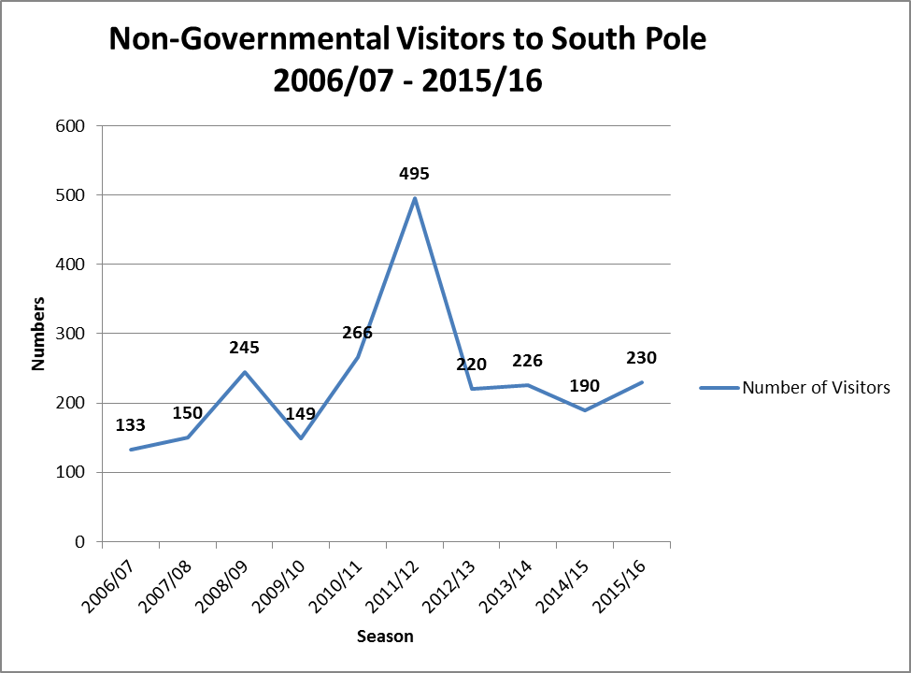
Figure 1: Number of Non-Governmental Visitors to the South Pole 2006/07 – 2015/16.
The guidelines on overland access for Non-Governmental Visitors (NGVs) have been reviewed over 2015/16 with several changes proposed. The revised guidelines were reviewed by non-governmental expedition organizers and by IAATO. The revised ‘Guidelines for Non-Governmental Visitor Overland Approach to the South Pole’ are included in Appendix Two. These will be trialled over 2016/17 with a view to adoption with the Management Plan in 2017.
All non-governmental expeditions are requested to advise Amundsen-Scott South Pole Station of their location and plans at least 24 hours in advance of their anticipated arrival at the South Pole. This is requested in view of safety considerations because aircraft and vehicles operate around the clock at South Pole to service scientific and station needs. Awareness of non-governmental expedition movements helps South Pole station personnel plan activities, and also provides the opportunity for the station to advise approaching expeditions of any local incidents or concerns.
Approach routes from the Ronne Ice Shelf / Hercules Inlet and McMurdo / Ross Ice Shelf directions and procedures when approaching close to the skiway have been clarified. Further work is needed on other provisions related to non-governmental aircraft movements and practical procedures for station access, and this will be completed in 2016.
Management zones and sectors
The arrangement of management zones and sectors within the ASMA is being evaluated as part of the management plan review. Since the existing management plan was adopted there have been several important changes to South Pole logistics, the most important of which has been relocation of the skiway so that it no longer overlaps with the Clean Air Sector. However, relocation has resulted in a small overlap of the skiway with the edge of the Quiet Circle. In addition, there is a continual need to dispose of blowing snow accumulating in the lee of station structures, and to remove the snow to an area several kilometers downwind of the station. At present snow is disposed within the Quiet Circle and within the Dark Sector, which are the few practical options available for snow disposal owing to other constraints.
The Quiet Circle aims to minimize the number of sources of vibration near to the South Pole Remote Earth Science and Seismological Observatory (SPRESSO), which lies around eight kilometers from Amundsen-Scott South Pole station. Consideration is being given to reducing the size of the Quiet Circle so practical operational needs can be met without entering this area.
The original 1956/57 South Pole Station became buried by snow and was decommissioned in 1975. When the ASMA was adopted in 2007, a Hazardous Zone was designated around the buried station because of potential risks from sub-surface structures and cavities. Remediation of the hazard has begun but is not yet completed and as such will continue to be designated a Hazardous Zone until further notice. A second Hazardous Zone associated with the skiway would be retained.
The extent and configuration of the Operations Zone will be evaluated in relation to other zones and sectors as part of the management plan review.
In general the Sectors defined under the ASMA appear to be achieving their objectives by separating potentially conflicting uses and scientific experiments. Some relatively minor incursions into the Clean Air Sector have been observed from time to time, although this is being addressed by improvements to signposting and markers at the boundary of this Sector. Further analysis of the Sectors will be undertaken over the coming year in consultation with stakeholders.
Summary
Activities at the South Pole are diverse and complex, and are operating in an extreme environment. Priority is accorded to scientific research, and safety is a primary consideration. A wide range of scientific investigations are supported at Amundsen-Scott South Pole Station, with strong international collaboration. For example, research is being undertaken on topics such as the cosmic microwave background, space weather implications for global communications, and long-term observations of seismic characteristics and atmospheric gases that serve as vital global baselines for comparisons. These experiments, among others, exploit unique properties of the South Pole location to scientific advantage, and it is important that these properties are maintained and protected to ensure results are robust and not subject to undue interference.
ASMA No. 5 Amundsen-Scott South Pole Station, South Pole, aims to maximize valuable scientific opportunities at the South Pole, protect the near-pristine environment, and ensure that all activities can be conducted safely, environmentally responsibly and without disruption to scientific programs.
Revision of the ASMA management plan currently being conducted by the United States and Norway is an opportunity to review carefully the provisions of the plan against current activities and scientific programs, and make the adjustments needed. Establishment of the Management Group with Norway as a partner, and establishing a broad stakeholder group of both leading scientists and non-governmental interests, including IAATO, have been important developments over the past year as the management plan review is progressing.
The United States and Norway look forward to collaborating further on the revisions, and continue to extend an open invitation to other Parties and stakeholders whom may wish to contribute to become involved. Subject to any unforeseen circumstances, the United States and Norway anticipate being in a position to submit a revised management plan for consideration by the Antarctic Treaty Consultative Meeting in 2017.

